**QbCheck**

*Design Specification*

Version history

| **Date** | **Revision** | **By** | **Changes** |
| --- | --- | --- | --- |
| 2014-10-20 | A | DZ | First version |

**Table of Contents**

1. Use Cases

Use Case 0: Landing page(During Limited Testing)

Happy Path:

Exception Path:

Use Case 1: Landing page

Happy Path:

Exception Path:

Use Case 2: Enter patient info

Happy Path:

Exception Path:

Exception Path:

Use Case 4: View test instructions “Prepare”

Happy Path:

Exception Path:

Use Case 5: Computer Check page, Test Prepare (child page)

Happy Path:

Exception Path:

Use Case 6: Perform practice test

Happy Path:

Exception Path:

Use Case 7: Start test, Test “Perform”

Happy Path:

Use Case 8: CPT

Happy Path:

Exception Path:

Use Case 9: Thank you page

Happy Path:

Exception Path:

[Use Case 10: Payment Page](https://docs.google.com/a/qbtech.com/document/d/16WI8wSdO3lGdWp4v8wEaksEGxn3giJPqzbBRZYQE7C8/edit#heading=h.a2k9u5lbym6c)

[Happy Path:](https://docs.google.com/a/qbtech.com/document/d/16WI8wSdO3lGdWp4v8wEaksEGxn3giJPqzbBRZYQE7C8/edit#heading=h.e6ku8f314e66)

[Exception Path:](https://docs.google.com/a/qbtech.com/document/d/16WI8wSdO3lGdWp4v8wEaksEGxn3giJPqzbBRZYQE7C8/edit#heading=h.opxelhs3gtg3)

Use Case 11: Test Report Page

Happy Path:

Exception Path:

Use Case 12: Create Test Subject

Happy Path:

Exception Path:

Use Case 13: Read Test Subject

Happy Path:

Exception Path:

Use Case 14: Update Test Subject

Happy Path:

Exception Path:

Use Case 15: List Test Subject

Happy Path:

Exception Path:

Use Case 16: Delete Test Subject

Happy Path:

Exception Path:

Use Case 17: Search Test Subject

Happy Path:

Exception Path:

Use Case 18: Create Site

Happy Path:

Exception Path:

Use Case 19: Read Site

Happy Path:

Use Case 20: Update Site

Happy Path:

Exception Path:

Use Case 21: List Site

Happy Path:

Exception Path:

Use Case 22: Delete Site

Happy Path:

Exception Path:

Use Case 23: Search Site

Happy Path:

Exception Path:

Use Case 24: Create User

Happy Path:

Exception Path:

Use Case 25: Read User

Happy Path:

Use Case 26: Update User

Happy Path:

Exception Path:

Use Case 27: List User

Happy Path:

Exception Path:

Use Case 28: Delete User

Happy Path:

Exception Path:

Use Case 29: Search User

Happy Path:

Exception Path:

[Use Case 30: Create One Voucher](https://docs.google.com/a/qbtech.com/document/d/16WI8wSdO3lGdWp4v8wEaksEGxn3giJPqzbBRZYQE7C8/edit#heading=h.noli412vhfq4)

[Happy Path:](https://docs.google.com/a/qbtech.com/document/d/16WI8wSdO3lGdWp4v8wEaksEGxn3giJPqzbBRZYQE7C8/edit#heading=h.11lgf580i461)

[Exception Path:](https://docs.google.com/a/qbtech.com/document/d/16WI8wSdO3lGdWp4v8wEaksEGxn3giJPqzbBRZYQE7C8/edit#heading=h.yvqsrkuibush)

[Use Case 31: Read Voucher](https://docs.google.com/a/qbtech.com/document/d/16WI8wSdO3lGdWp4v8wEaksEGxn3giJPqzbBRZYQE7C8/edit#heading=h.9b61jnpfj21t)

[Happy Path:](https://docs.google.com/a/qbtech.com/document/d/16WI8wSdO3lGdWp4v8wEaksEGxn3giJPqzbBRZYQE7C8/edit#heading=h.fpplu01jt3u3)

[Use Case 33: List Voucher](https://docs.google.com/a/qbtech.com/document/d/16WI8wSdO3lGdWp4v8wEaksEGxn3giJPqzbBRZYQE7C8/edit#heading=h.es3f0g3phndc)

[Happy Path:](https://docs.google.com/a/qbtech.com/document/d/16WI8wSdO3lGdWp4v8wEaksEGxn3giJPqzbBRZYQE7C8/edit#heading=h.46nxrxysewxa)

[Exception Path:](https://docs.google.com/a/qbtech.com/document/d/16WI8wSdO3lGdWp4v8wEaksEGxn3giJPqzbBRZYQE7C8/edit#heading=h.880xtjisqw6z)

[Use Case 34: Delete Voucher](https://docs.google.com/a/qbtech.com/document/d/16WI8wSdO3lGdWp4v8wEaksEGxn3giJPqzbBRZYQE7C8/edit#heading=h.4uzemb57ecus)

[Happy Path:](https://docs.google.com/a/qbtech.com/document/d/16WI8wSdO3lGdWp4v8wEaksEGxn3giJPqzbBRZYQE7C8/edit#heading=h.gmyoalgzw4de)

[Use Case 35: Search Voucher](https://docs.google.com/a/qbtech.com/document/d/16WI8wSdO3lGdWp4v8wEaksEGxn3giJPqzbBRZYQE7C8/edit#heading=h.mmf1dxdx24hj)

[Happy Path:](https://docs.google.com/a/qbtech.com/document/d/16WI8wSdO3lGdWp4v8wEaksEGxn3giJPqzbBRZYQE7C8/edit#heading=h.5t9v2o8bjpuw)

[Exception Path:](https://docs.google.com/a/qbtech.com/document/d/16WI8wSdO3lGdWp4v8wEaksEGxn3giJPqzbBRZYQE7C8/edit#heading=h.m74wtuu4ourj)

Use Case 36: Read Transaction

Happy Path:

Use Case 37: List Transaction

Exception Path:

Use Case 38: Search Transaction

Happy Path:

Exception Path:

[Use Case 39: Create Vouchers In Group](https://docs.google.com/a/qbtech.com/document/d/16WI8wSdO3lGdWp4v8wEaksEGxn3giJPqzbBRZYQE7C8/edit#heading=h.3sqs9yj5ok8c)

[Happy Path:](https://docs.google.com/a/qbtech.com/document/d/16WI8wSdO3lGdWp4v8wEaksEGxn3giJPqzbBRZYQE7C8/edit#heading=h.jq5573xwenh2)

[Exception Path:](https://docs.google.com/a/qbtech.com/document/d/16WI8wSdO3lGdWp4v8wEaksEGxn3giJPqzbBRZYQE7C8/edit#heading=h.tvjc7bcqo47h)

Use Case 40: View Faq Page

Happy Path:

Use Case 41: View More On Adhd Page

Happy Path:

Use Case 42: View About The Test Page

Happy Path:

Use Case 43: View Pricing Page

Happy Path:

Use Case 44: Sign In

Happy Path:

Exception Path:

[Use Case 45: Permanent Link To Result Report](https://docs.google.com/a/qbtech.com/document/d/16WI8wSdO3lGdWp4v8wEaksEGxn3giJPqzbBRZYQE7C8/edit#heading=h.uhuqfs1oyho0)

[Happy Path:](https://docs.google.com/a/qbtech.com/document/d/16WI8wSdO3lGdWp4v8wEaksEGxn3giJPqzbBRZYQE7C8/edit#heading=h.maz0loe3fpl7)

[Exception Path:](https://docs.google.com/a/qbtech.com/document/d/16WI8wSdO3lGdWp4v8wEaksEGxn3giJPqzbBRZYQE7C8/edit#heading=h.gbwvjwhvgwei)

Use Case 46: Download Result Report

Happy Path:

Exception Path:

[Use Case 47: Share Result Report](https://docs.google.com/a/qbtech.com/document/d/16WI8wSdO3lGdWp4v8wEaksEGxn3giJPqzbBRZYQE7C8/edit#heading=h.ta9s1hvru7cy)

[Happy Path:](https://docs.google.com/a/qbtech.com/document/d/16WI8wSdO3lGdWp4v8wEaksEGxn3giJPqzbBRZYQE7C8/edit#heading=h.lklnzs7dkx3p)

[Exception Path:](https://docs.google.com/a/qbtech.com/document/d/16WI8wSdO3lGdWp4v8wEaksEGxn3giJPqzbBRZYQE7C8/edit#heading=h.1f9xzrvhgzxq)

Use Case 48: Can’t Take Test On Mobile Phone

Happy Path:

Exception Path:

Use Case 49: System Unavailable

Happy Path:

[Use Case 50: Print Voucher Code Table](https://docs.google.com/a/qbtech.com/document/d/16WI8wSdO3lGdWp4v8wEaksEGxn3giJPqzbBRZYQE7C8/edit#heading=h.tf1uucl5tw5e)

[Happy Path:](https://docs.google.com/a/qbtech.com/document/d/16WI8wSdO3lGdWp4v8wEaksEGxn3giJPqzbBRZYQE7C8/edit#heading=h.pv58w8kxfjn3)

[Exception Path:](https://docs.google.com/a/qbtech.com/document/d/16WI8wSdO3lGdWp4v8wEaksEGxn3giJPqzbBRZYQE7C8/edit#heading=h.7ipt61k2ases)

Use Case 51: Menu Page

Happy Path:

Exception Path:

Use Case 52: Sign Out

Happy Path:

Exception Path:

[Use Case 53: Email Result Report](https://docs.google.com/a/qbtech.com/document/d/16WI8wSdO3lGdWp4v8wEaksEGxn3giJPqzbBRZYQE7C8/edit#heading=h.2f0wbdx22u6g)

[Happy Path:](https://docs.google.com/a/qbtech.com/document/d/16WI8wSdO3lGdWp4v8wEaksEGxn3giJPqzbBRZYQE7C8/edit#heading=h.kynvsuubssmj)

[Exception Path:](https://docs.google.com/a/qbtech.com/document/d/16WI8wSdO3lGdWp4v8wEaksEGxn3giJPqzbBRZYQE7C8/edit#heading=h.t35fabrlrhpx)

Use Case 54: Test Subject Page

Happy Path:

Exception Path:

Use Case 55: Create Transaction

Happy Path:

Exception Path:

Use Case 56: Sign Up Page

Happy Path:

Exception Path:

Use Case 57: Administration Page

Happy Path:

Exception Path:

Use Case 58: Site Information

Happy Path:

Use Case 59: Billing Information

Happy Path:

Use Case 59: Billing Information(Modified)

Happy Path:

Use Case 60: Change Password

Happy Path:

Use Case 61: Update Personal Account Information

Happy Path:

Use Case 62: Age Control

Happy Path:

Use Case 63: Test Complete Conditions

Happy Path:

Use Case 64: Test Quality Parameters

Happy Path:

Exception Path:

Use Case 65: Questionnaire

Happy Path:

Exception Path:

Use Case 66: Two Factor Authentication

Happy Path:

Exception Path:

[Use Case 67: Voucher Code Expiry And Export](https://docs.google.com/a/qbtech.com/document/d/16WI8wSdO3lGdWp4v8wEaksEGxn3giJPqzbBRZYQE7C8/edit#heading=h.xyohw92pt19u)

[Happy Path:](https://docs.google.com/a/qbtech.com/document/d/16WI8wSdO3lGdWp4v8wEaksEGxn3giJPqzbBRZYQE7C8/edit#heading=h.6uy6bf3g69m)

[Exception Path:](https://docs.google.com/a/qbtech.com/document/d/16WI8wSdO3lGdWp4v8wEaksEGxn3giJPqzbBRZYQE7C8/edit#heading=h.df6empjacjf)

Use Case 68: Saving of Data

Happy Path:

Exception Path:

2. Wireframes and design

3. JavaScript Resources

# 

# 

# **1. Use Cases**

The use cases are divided on the base of the actors and there will be N different kind of actors:

1. Test Subject
2. Professional Users
3. System Admin
4. System itself

## Use Case 0: Landing page(During Limited Testing)

**User:** Test Subject,Professional user, System Admin

### Happy Path:

1. Enter the base URL a login form will appear.
2. Here the user have two options, (a) to proceed with voucher code, (b) a field for QbTest patient id and a field for access code.
3. A button “GO” when clicked after validating the fields the user will be redirected to the landing page use case 1.

### Exception Path:

1. Page is not found
2. Proper error message should be displayed

## Use Case 1: Landing page

**User:** Test Subject, System Admin , Professional user

### Happy Path:

1. The page should have a Sign up button(use case 56) for with text above “For Professional Users only” mentioned.
2. The header includes the following:
   1. About the test(/qbcheck)
   2. About ADHD(/adhd)
   3. Common questions (/faqs)
   4. Pricing
   5. Login for Pro Users
   6. Option to choose language using flags (english/swedish)
3. The Footer Includes the following
   1. Data privacy
   2. Terms of use (include both Terms and Conditions and Intended Use)
   3. Contact
   4. E-mail addresses under Contact
      1. cancellation.qbcheck@qbtech.com (for cancellation of contracts)
      2. enquiries.qbcheck@qbtech.com (for general inquires)
      3. technicalsupport.qbcheck@qbtech.com (for technical support)
      4. personaldata.qbcheck@qbtech.com (for inquiries about data privacy)

### Exception Path:

1. Page is not found
2. Proper error message should be displayed

## 

## Use Case 2: Enter patient info

**User**: Professional User

### Happy Path:

1. If the user click on “New Test” button when logged into QbCheck for professionals than user will be able to see the page
2. Check browser compatibility, The warning message should be “Please note, to perform a QbCheck you must use the Chrome or Firefox web browsers
3. Info page contains The headline "Enter personal data". There should be an i icon next to "Enter personal data", when clicked a popup window should be displayed with an info text about data privacy. "Data privacy: Age and gender information is needed in order for QbCheck to be able to compare your result to the right norm group. However, individual data is not stored so that a specific person can be identified."
4. The page should also contain a check box saying ‘Consent taken’. This box should be checked if the administrator has collected the consent needed. Only when checked should it be possible to continue to the next page. A link to the PDF document “Patien Consent..” should also be available under the check box.
5. Popup (for reference of desired look please see example twitter bootstrap javascript popover)
6. The following fields will be displayed and available to fill the rest of the data:
   1. date of birth
   2. gender
7. The button should be labeled "Next"
8. system must check that age belong to the interval [min age, max age], i.e. min=6.0 years, max=60.9 years
9. If test subject age is below 18 years then a modal window should be displayed with the following content “To continue with the QbCheck you need permission from your parents or legal guardian. Confirm this by clicking OK…”
10. On correct input user will be redirected to use case 3 or 4 depending on the age.

### Exception Path:

1. Missing required fields
2. Page is not found
3. Proper error message should be displayed:
   1. if no birthdate is specified “Please enter the birth date”
   2. if birth date is out of range, see here

**Use Case 3: Welcome Page**

1. Users are directed to Welcome page after the registration page.
2. User with age > 18 is directed directly to welcome page after registration.
3. User with age < 18 is directed from warning window that is displayed for non-adults.

### Exception Path:

1. Missing required fields
2. Page is not found
3. Proper error message should be displayed:
   1. If user data is lost, goto registration page with proper error.

## Use Case 4: View test instructions “Prepare”

**User**: Professional User

### Happy Path:

1. Following use case 3, user is directed to test page
2. There should be a video here showing the instructions on how to perform a QbCheck. The video is an embedded Wistia video for either Child version or Adult version (URL depends on customer age from Customer Registration step). The video is the main element of the page.
3. Located below is the progress bar and then a button saying “Read text Instructions instead”. If that button is clicked, a text version of the instructions is unfolded.
4. The button for “Go To Computer Check” should not be activated until the instructions video has started or the user has pressed the Text instead-button.
5. When the user is done with this section he/ she clicks on the next step in the progress bar to continue (goes to Use Case 5).

### Exception Path:

1. Page is not found
2. Proper error message should be displayed

## Use Case 5: Computer Check page, Test Prepare (child page)

**User**: Test Subject, Professional User

### Happy Path:

1. Following above use case, user is directed to test flow page “Prepare section”.
2. User will be able to see the the child page, with the message We will now check if the camera and computer can track your face and is fast enough. Tracking your activity through the camera is an important part of the test, but you are not recorded at any time. Only your activity data will be saved.
3. A pop up message appears saying: “To get started - allow access to your camera above”
4. The following options will be available for camera and computer check
   1. Detecting face
   2. Measuring FOV (field of view)
   3. Checking computer performance
5. If everything is ok user will be redirected to use case 6.

### Exception Path:

1. The user has not pressed ‘Allow camera’
2. Give proper error message for failing computer requirement
3. The error message should be different depending on if it is the first fail or not:
   1. 1st fail: “Sorry, the camera check failed. Please try the camera check again.”
   2. 2nd fail: “Sorry, the camera check failed. Please make sure you don’t have a window or light directly behind you. Also please close any open programs on your computer. Then try again.”
   3. 3rd fail: “Sorry, it seems like your computer is not fast enough. Please try on another computer if possible.”
4. Error message should have a button to start computer check again.
5. It restarts the use case 5 , except allowing access and pop up are not shown again.

## Use Case 6: Perform practice test

**User**: Test Subject, Professional User

### Happy Path:

1. Follow steps from use case 4 or 5.
2. User will be able to see the page
3. This section will have a main content area with an embedded instruction video (Wistia) to the right and a smaller text area to left of the video. There should be different videos depending on the age and gender of the user.
4. A button (Text "When you are ready:" Button label: "Start the practice test)
5. When scrolling down under the button written test instructions should be displayed
6. When clicked it should start 1 minute practice test.
7. If test is ok, the user is directed to take test,

### Exception Path:

1. If practice test is not ok an error message and a chance to “Review test instructions” “Do the practice test again” (start the practice test again in full screen) will be given. The error message should be:  
   “There were too many errors in the practice test, please review the test instructions and try again”.
2. If no button presses were recorded, this error message should be displayed:
3. “No button presses were recorded. Please use the spacebar and try the practice test again.
4. If you are on a Mac, please make sure that the web browser is not in full screen mode and try again”.
5. If practice test is ended before completing following error message should be displayed: “Practice test is not complete, Please take the practice test again.”
6. Page is not found
7. Proper error message should be displayed

## Use Case 7: Start test, Test “Perform”

**User**: Test Subject

### Happy Path:

1. If use case 6 succeed, The message should be displayed as “Well done! You are now ready to start the test!” and a new button with title “Start QbCheck” will be shown.
2. If clicked (goes to use case 8).

**Exception Path:**

1. Page is not found
2. Proper error message should be displayed

## Use Case 8: CPT

**User**: Test Subject, Professional User

### Happy Path:

1. If use case 7 succeed, The canvas will open in full screen (HTML5 API)
2. The CPT will start automatically and continue for 15/20 minutes
3. The CPT will end and go back to the normal screen
4. User is directed to welcome page at the end of test.

### Exception Path:

1. Full screen is not available
2. Proper error message should be shown and the user taken back to Use Case 5
3. The page is not found

## Use Case 9: Thank you page

### Happy Path:

1. After the test taken, the thank you page should be displayed.
2. It contains a thank you message with small description
3. There is button with text “Get Report” to view the result

### Exception Path:

1. Page is not found
2. Proper error message should be displayed

## Use Case 11: Test Report Page

**User**: Test Subject, System Admin, Professional User

### Happy Path:

1. After directed to report page
2. Report elements should be displayed
3. A button to download the report in PDF.

### Exception Path:

1. Page is not found
2. Proper error message should be displayed

## Use Case 12: Create Test Subject

**User**: Professional User, System Admin

### Happy Path:

1. Login to the application using valid credentials(username,password).
2. You will be able to see three options “New Test”, “Existing Test, and “Administration”.
3. Click on the “New Test” button. You will be directed to the Enter Personal Information page to fill out gender and date of birth of the test subject.
4. Patient consent should be collected and then the check box for patient consent taken should be checked as well in order to create and save the test subject.
5. A patientId will be automatically generated and assigned to the patient and the system will automatically create the test subject.

### Exception Path:

1. Follow steps 1-5 from the above mentioned scenario.
2. Any field missing from the mandatory ones.
3. Fields data are not in correct format.
4. Click on “Proceed to test” button. It doesn’t get saved and proper error message should be displayed with exact error fields mentioned.

## Use Case 13: Read Test Subject

**User**: Professional User, System Admin

### Happy Path:

1. Login to the application using valid credentials(username,password).
2. You will be able to see the page with menu.
3. Click on the “Select Existing Test” button from the Existing Test menu.
4. The Test Subjects list will open up.
5. If the user is Professional User, list of Test Subjects of that **particular site** will be displayed in a table. If the user is **System Admin,** list of test subjects of all the sites will be displayed.
6. This table should contain :
7. id ((Link, will lead to use case 54)
8. patient-ID number
9. date of birth
10. gender
11. last test (date)
12. site id
13. status (completed/not completed)
14. number of tests
15. open last report (small glyphicon)
16. The id number should link to a Test Subject page where Test Subject data can be reviewed and changed. This page should also list all tests this subject has done with test date and a link to open up the test report.

### Exception Path:

1. Follow steps 1-4 from the above mentioned scenario.
2. Page is not found
3. Proper error message should be displayed

## Use Case 14: Update Test Subject

**User**: Professional User,System Admin

### Happy Path:

1. Login to the application using valid credentials(username,password).
2. You will be able to see the page with menu.
3. Click on the “Select Existing Test” button from the Existing Test menu.
4. The Test Subjects list will open up.
5. If the user is Professional User, list of Test Subjects of that **particular site** will be displayed in a table. If the user is **System Admin,** list of test subjects of all the sites will be displayed.
6. This table should contain :
7. id ((Link, will lead to use case 54)
8. patient-ID number
9. date of birth
10. gender
11. last test (date)
12. site id
13. status (completed/not completed)
14. number of tests
15. open last report (small glyphicon)
16. Click on edit icon on any row and you can edit the fields.
17. The id number should link to a Test Subject page where Test Subject data can be reviewed and changed. This page should also list all tests this subject has done with test date and a link to open up the test report.

### Exception Path:

1. Follow steps 1-4 from the above mentioned scenario.
2. Page is not found
3. Proper error message should be displayed

## Use Case 15: List Test Subject

**User**: Professional User,System Admin

### Happy Path:

1. Login to the application using valid credentials(username,password).
2. You will be able to see the page with menu.
3. Click on the “Select Existing Test” button from the Existing Test menu.
4. The Test Subjects list will open up.
5. If the user is Professional User, list of Test Subjects of that **particular site** will be displayed in a table. If the user is **System Admin,** list of test subjects of all the sites will be displayed.
6. This table should contain :
7. id ((Link, will lead to use case 54)
8. patient-ID number
9. date of birth
10. gender
11. last test (date)
12. site id
13. status (completed/not completed)
14. number of tests
15. open last report (small glyphicon)

### Exception Path:

1. Follow steps 1-4 from the above mentioned scenario.
2. Page is not found
3. Proper error message should be displayed

## Use Case 16: Delete Test Subject

**User**: Professional User,System Admin

### Happy Path:

1. Login to the application using valid credentials(username,password).
2. You will be able to see the page with menu.
3. Click on the “Select Existing Test” button from the Existing Test menu.
4. The Test Subjects list will open up.
5. If the user is Professional User, list of Test Subjects of that **particular site** will be displayed in a table. If the user is **System Admin,** list of test subjects of all the sites will be displayed.
6. This table should contain :
7. id ((Link, will lead to use case 54)
8. patient-ID number
9. date of birth
10. gender
11. last test (date)
12. site id
13. status (completed/not completed)
14. number of tests
15. open last report (small glyphicon)
16. There will be a delete icon in each row. Clicking on it will delete the test subject.

### Exception Path:

1. Follow steps 1-4 from the above mentioned scenario.
2. Page is not found
3. Proper error message should be displayed

## Use Case 17: Search Test Subject

**User**: Professional User, System Admin

### Happy Path:

1. Login to the application using valid credentials(username,password).
2. You will be able to see the page with menu.
3. Click on the “Select Existing Test” button from the Existing Test menu.
4. The Test Subjects list will open up.
5. If the user is Professional User, list of Test Subjects of that **particular site** will be displayed in a table. If the user is **System Admin,** list of test subjects of all the sites will be displayed.
6. This table should contain :
7. id ((Link, will lead to use case 54)
8. patient-ID number
9. date of birth
10. gender
11. last test (date)
12. site id
13. status (completed/not completed)
14. number of tests
15. open last report (small glyphicon)
16. In the search form at the top of the list, select the appropriate search criteria (e.g. “Date Registered”) and fill the text field with the search criteria with the date.
17. Click on the “Search” button. As a result the displayed list should be repopulated to show the test subject(s) that fulfil the search criteria

### Exception Path:

1. Follow steps 1-4 from the above mentioned scenario.
2. Use of illegal characters in searching, proper error message should be displayed.
3. Page is not found

## Use Case 18: Create Site

**User**: System Admin

### Happy Path:

1. Login to the application using valid credentials(username,password).
2. You will be able to see the page with menu.
3. Navigate to the Sites in the menu
4. List of sites will be displayed in a grid. The top row will be empty where user can enter new site details, the fields are:
   1. Id(auto generated)
   2. Name
   3. Country ID
   4. Email
   5. Telephone
   6. State
   7. Payment Method
   8. CustomerID(will be provided by Braitree upon validating credit card information, it is optional field)
   9. BillingAddress (streetAddress1,streetAddress2,city,state,zip)
   10. VisitAddress (streetAddress1,streetAddress2,city,state,zip)
   11. Notes (optional)
5. Fill in the fields and click on ‘save’ button. The site should get saved successfully and a new row will appear in the grid view.

### Exception Path:

1. Follow steps 1-6 from the above mentioned scenario.
2. Any field missing from the mandatory ones.
3. Fields data are not in correct format.
4. Click on “Create” button. It does not get saved and proper error message should be displayed with exact error fields mentioned.

## Use Case 19: Read Site

**User:** System Admin

### Happy Path:

1. Login to the application using valid credentials(username,password).
2. You will be able to see the page with menu.
3. Navigate to the Sites in the menu
4. List of sites will be displayed in a grid. You can use the search featureto narrow down this list.
5. Click on the details link in the row, a small box will open with the site information
6. Also when clicking on the details link, billingAddress and visitAddress details will be open below the grid where they can be edited.

## Use Case 20: Update Site

**User:** System Admin

### Happy Path:

1. Login to the application with valid credentials(username,password).
2. You will be able to see the page with menu.
3. Navigate to the Sites in the menu
4. You will see all the sites. Use the search feature if required in order to narrow down this list.
5. Click on the edit icon in the row, and you will be able to edit that site.
6. After editing, click on the save icon in the row to get it saved successfully.

### Exception Path:

1. Follow steps 1-7 from the above mentioned scenario.
2. Any field left empty from the mandatory ones.
3. Fields data not in correct format.
4. Click on “Update” button. It doesn’t get saved and proper error message should be displayed with exact error fields mentioned.

## Use Case 21: List Site

**User:** System Admin

### Happy Path:

1. Login to the application using valid credentials(username,password).
2. You will be able to see the page with menu.
3. Navigate to the Sites in the menu
4. List of Sites will be displayed in a grid.(ID, Name, Country ID, Email, Telephone, billingAddress,visitAddress, payment method, customerID, status Notes).

### Exception Path:

1. Page is not found

## Use Case 22: Delete Site

**User:** System Admin

### Happy Path:

1. Login to the application using valid credentials(username,password).
2. You will be able to see the page with menu.
3. Navigate to the Sites in the menu.
4. A list of all the sites will be displayed. Find the site that you would like to delete (you can use the search feature) and click on the delete icon of the row you want to delete. A pop up confirmation will open.
5. Click on “Yes” to proceed with the delete. The site should be deleted and the page should be refreshed with a confirmation message showing the delete.

### Exception Path:

1. Follow steps 1-5 from the above mentioned scenario.
2. Page is not found

## Use Case 23: Search Site

**User:** System Admin

### Happy Path:

1. Login to the application using valid credentials(username,password).
2. You will be able to see the page with menu.
3. Navigate to the Sites in the menu
4. List of Sites will be displayed in a grid.(ID,Name, Country ID, Email, Telephone,visitAddress, billingAddress, paymentMethod Notes).
5. In the search form at the top of the list, select the appropriate search criteria (e.g. “Site Name”) and fill the text field with the search criteria with any site name.
6. Click on the “Search” button. As a result the displayed list should be repopulated to show the site(s) that fulfil the search criteria.

### Exception Path:

1. Follow steps 1-6 from the above mentioned scenario.
2. Use of illegal characters in searching, proper error message should be displayed.

## Use Case 24: Create User

**User**: System Admin

### Happy Path:

1. Login to the application using valid credentials(username,password).
2. You will be able to see the page with menu.
3. Navigate to the Users in the menu
4. A list of all the users will appear with an empty row at the top of the list. To add new user, following fields are there
   1. SiteID(auto generated)
   2. Email
   3. Password
   4. FirstName
   5. LastName
   6. Telephone
   7. DateFormat

The best would be to have a dropdown with the following choices:

MM/dd/yyyy (default)

dd/MM/yyyy

yyyy-MM-dd

dd-MM-yyyy

dd.MM.yyyy

* 1. Language
  2. Privilege Level

1. Fill in the fields and click on ‘save’ icon. The User should get saved successfully and a new row will appear in the list.

### Exception Path:

1. Follow steps 1-6 from the above mentioned scenario.
2. Any field missing from the mandatory ones.
3. Fields data are not in correct format.
4. Click on “Create” button. It shouldn’t get saved and proper error message should be displayed with exact error fields mentioned.

## Use Case 25: Read User

**User:** System Admin

### Happy Path:

1. Login to the application using valid credentials(username,password).
2. You will be able to see the page with menu.
3. Navigate to the Users in the menu
4. List of users will be displayed in a grid. You can use the search featureto narrow down this list.
5. Click on the details link in the row of the user you want to see the details of. A small box will open with that user details.

## Use Case 26: Update User

**User:** System Admin

### Happy Path:

1. Login to the application with valid credentials(username,password).
2. You will be able to see the page with menu.
3. Navigate to the Users in the menu
4. You will see all the users. Use the search feature if required in order to narrow down this list.
5. Click on the edit icon of the row you want to edit.
6. Edit the desired field(s) and click on “save” icon. It should get saved successfully.

### Exception Path:

1. Follow steps 1-7 from the above mentioned scenario.
2. Any field left empty from the mandatory ones.
3. Fields data not in correct format.
4. Click on “Update” button. It shouldn’t get saved and proper error message should be displayed with exact error fields mentioned.

## Use Case 27: List User

**User:** System Admin

### Happy Path:

1. Login to the application using valid credentials(username,password).
2. You will be able to see the page with menu.
3. Navigate to the Users in the menu
4. List of Users will be displayed in a grid (id, siteID, email, password, firstname, lastname, last login, telephone, dateformat, language, salt, privilege_level).

### Exception Path:

1. Follow steps 1-4 from the above mentioned scenario.
2. Page is not found

## Use Case 28: Delete User

**User:** System Admin

### Happy Path:

1. Login to the application using valid credentials(username,password).
2. You will be able to see the page with menu.
3. Navigate to the Users in the menu.
4. A list of all the users will be displayed. Find the user that you would like to delete (you can use the search feature) and click on the delete icon of the row you want to delete. A pop up confirmation will appear.
5. Click on “Yes” to proceed with the delete. The user should be deleted and the page should be refreshed with a confirmation message showing the delete.

### Exception Path:

1. Follow steps 1-5 from the above mentioned scenario.
2. Page is not found

## Use Case 29: Search User

**User:** System Admin

### Happy Path:

1. Login to the application using valid credentials(username,password).
2. You will be able to see the page with a menu.
3. Navigate to the Users in the menu
4. List of Users will be displayed in a grid (id, siteID, email, password, firstname, lastname, last login, telephone, dateformat, language, salt, privilege_level).
5. In the search form at the top of the list, select the appropriate search criteria (e.g. “Email”) and fill the text field with the search criteria with any site name.
6. Click on the “Search” button. As a result the displayed list should be repopulated to show the user(s) that fulfil the search criteria.

### Exception Path:

1. Follow steps 1-6 from the above mentioned scenario.
2. Use of illegal characters in searching, proper error message should be displayed.

## Use Case 36: Read Transaction

**User**: System Admin

### Happy Path:

1. Login to the application using valid credentials(username,password).
2. You will be able to see the page with a menu.
3. Navigate to the Transactions in the menu
4. List of transactions will be displayed in a grid (testresultID, date, type (credit card, billed), status).
5. Click on any row to view details of that specific transaction.You will be redirected to the page with that transactions’s details.

## Use Case 37: List Transaction

**User**: System Admin

**Happy Path:**

1. Login to the application using valid credentials(username,password).
2. You will be able to see the page with menu.
3. Navigate to the Transactions in the menu
4. List of Transactions will be displayed in a grid (testresultID, date, type (, credit card, billed), status).

### Exception Path:

1. Follow steps 1-4 from the above mentioned scenario.
2. Page is not found

## Use Case 38: Search Transaction

**User**: System Admin

### Happy Path:

1. Login to the application using valid credentials(username,password).
2. You will be able to see the page with a menu.
3. Navigate to the Transactions in the menu.
4. List of Users will be displayed in a grid (testresultID, date, type (credit card, billed), status).
5. In the search form at the top of the list, select the appropriate search criteria (e.g. “Date”) and fill the text field with the search criteria with date.
6. Click on the “Search” button. As a result the displayed list should be repopulated to show the user(s) that fulfil the search criteria.

### Exception Path:

1. Follow steps 1-6 from the above mentioned scenario.
2. Use of illegal characters in searching, proper error message should be displayed.

## Use Case 40: View Faq Page

**User**: Test Subject, Professional User, System Admin

### Happy Path:

1. Open the site URL, the Landing Page will open
2. Go to the FAQ link in the page.
3. A new FAQ page will be open
4. The page will contain the most common questions and answers about the website and the questions asked by the customers.

## Use Case 41: View About Adhd Page

**User**: Test Subject, Professional User, System Admin

### Happy Path:

1. Open the site URL, the Landing Page will open
2. Go to the More on ADHD link in the page.
3. A new ADHD page will open which will contain the information about the disease.

## Use Case 42: View About The Test Page

**User**: Test Subject, Professional User, System Admin

### Happy Path:

1. Open the site URL, the Landing Page will open
2. Go to the About the Test link in the page.
3. A new About the Test page will open which will contain the information about the test and some generic instructions about the test and requirements.

## Use Case 43: View Pricing Page

**User**: Test Subject, Professional User, System Admin

### Happy Path:

1. Open the site URL, the Landing Page will open
2. Go to the Pricing link in the page.
3. A new Pricing page will open which will contain the information about the pricing details of the test and the offers.
4. There should be a button on the pricing page “Start test now” which redirects user for the new test.
5. Pricing page should be hidden now.

## Use Case 44: Sign In

**User**: Professional User, System Admin

### Happy Path:

1. Open the site URL, the Landing Page will open
2. Go to the Login for Pro Users in the page.
3. A new Sign In page will open which will contain user name and password fields.
4. After filling them, click on login button. It will take you to the page with a menu.
5. If the user is professional user and has payment method credit card and there is no information of his CustomerID from braintree, than this user should be redirected to billing information page(Use case 59)

### Exception Path:

1. Follow steps 1-3 from the above mentioned scenario.
2. By putting wrong credentials.
3. Proper error message should be displayed.

## Use Case 46: Download Result Report

**User**: Test Subject, Professional User, System Admin

### Happy Path:

1. When the test process is completed and the Test Result page appears.
2. In this page there will be a download button to download the report in PDF.
3. This button should be linked to Report Generator or it should be generated from java script(sample links, <https://github.com/MrRio/js> PDF or <http://www.tcpdf.org/> )

### Exception Path:

1. If the payment is not done.
2. Page is not found
3. Proper error message should be displayed.

## Use Case 48: Can’t Take Test On Mobile Phone

**User**: Professional User, System Admin, Test Subject

### Happy Path:

1. Open the site URL, the Landing Page will open.
2. If the site is opened in mobile or any other tablet a warning message should be shown on the first page in the patient registration flow (Patient Setup) and a Back to homepage button should be shown.
3. Moreover the test flow page should not be allowed to open in mobile.

### Exception Path:

1. Page is not found
2. Proper error message should be displayed

## Use Case 49: System Unavailable

**User**: Test Subject, Professional User, System Admin

### Happy Path:

1. Open the web URL.
2. If there is some error in the site proper error message should be displayed.
3. Or if the site is upgrading or under maintenance proper message should also be displayed for that.

## Use Case 51: Menu Page

**User**: Professional User, System Admin

### Happy Path:

1. Open the site URL, the Landing Page will open
2. Go to the Sign In link in the page.
3. A new Sign In page will open which will contain username and password fields.
4. After filling them, click on login button; it will take you to the page with a menu.
5. This page will contain a menu with the following options:
6. New Test
7. Existing Test
8. Administration
9. The New Test menu will contain:
10. Start New Test Now
11. The Existing Test menu will contain:
12. Select Existing Test Subject
13. The Administration menu will contain:
14. Site and Billing Information
15. The Page will also have a sign out link where user can be signed out safely.

### Exception Path:

1. Follow steps 1-3 from the above mentioned scenario.
2. By putting wrong credentials.
3. Proper error message should be displayed.

## Use Case 52: Sign Out

**User**: Professional User, System Admin

### Happy Path:

1. Open the site URL, the Landing Page will open
2. Go to the Sign In link in the page.
3. A new Sign In page will open which will contain user name and password fields.
4. After filling them click on log in button it will take you to the page with a menu.
5. After successfully sign in, all the pages will be open will contain a sign out link.
6. Click on the link to sign out successfully and return to a landing page.

### Exception Path:

1. Follow steps 1-3 from the above mentioned scenario.
2. By putting wrong credentials.
3. Proper error message should be displayed.

## Use Case 54: Test Subject Page

**User**: Professional User, System Admin

### Happy Path:

1. User will come to this from use case 13.
2. No extra page will open here.
3. Two new fields of that specific test subject are shown below the test subjects list
   1. Number of test
   2. Last test date
4. Below these fields there will be grid which will contain all the test the Test subject has given along with a date and a link to open that test report.

### Exception Path:

1. Page is not found
2. Proper error message should be displayed

## Use Case 55: Create Transaction

**User**: System itself

### Happy Path:

1. If the Professional User set the transaction type field to 3 if that site is billed using credit card retrieve its information from braintree and process the transaction, if its invoice base QbTech will handle this itself.
2. This use case will be done in background while showing the Test report.

### Exception Path:

1. Error occurred during transaction.
2. System is down

## Use Case 56: Sign Up Page

**User**: Professional Site / Professional User

### Happy Path:

1. There is a section with the headline “Ways QbCheck can aid in ADHD assessment”, This heading includes three parts “Informed to Act Early”, “Reliable Results”, and “Improve Patient Communication”.
2. Below this section, there is another section “Developed to Add Value to Your ADHD Assessment” which also has three parts “Test Patients at Home”, “Instantly Access Results”, and “Manage Testing Process”.
3. Next is the Sign Up form which includes a “Sign-Up Your Clinic” heading.
4. The text below this header is: “When you sign up, we will register your clinic’s own account. For secure access to your account and your patients’ results, you will get a software protection USB device. This will be sent to your postal address stated below with recommended mail within 2-5 business days. You are then ready to get started.When starting to use QbCheck, you will be offered unlimited testing for free during the first week included in your start up fee of $XX. The following months, there will be a monthly fee of $XX, which includes one free test. Additional tests are charged at a per test basis of $XX. You can pay by credit card or invoice. Please read through the Terms and Conditions below for more details.”
5. The fields are:
   1. Clinic details: site name, billing address, visit address and choice of payment form (credit card or billing)
   2. User details: Name, e-mail, password, telephone
6. If credit card is selected as the payment method, the billing address should be disabled.
7. When entering data into the e-mail field a message below should appear saying “Your e-mail address will be your user name for QbCheck”
8. When entering data into the password field a message below should appear saying “Please choose a password”
9. An email sent to Qbtech should have
   1. subject “New QbCheck site”
   2. body “There is a new QbCheck site registered with the following information”
      1. *|sitename|*
      2. *|email|*
      3. *|telephone|*
      4. *|billing address|*
      5. *|visit address|*
      6. *|prefered payment method|*
   3. The QbCheck registration robot “receipient: [info@qbtech.com](mailto:info@qbtech.com)”
   4. Language should be set based on country stated in address field.
10. There are number of check boxes:
    1. “I accept the terms and conditions” and a link to the pfd with terms and conditions for Prosumers
    2. “I accept the processing of my personal data” and a link to the pdf “Consent Form for Prosumers”.”
11. At form submission the user is returned to the landing page and a message is shown saying “Thank you. You will shortly receive a confirmation e-mail that your application has been registered.”

### Exception Path:

1. Error occurred during transaction.
2. Required field/invalid format error messages.

## Use Case 57: Administration Page

**User**: Professional User

### Happy Path:

1. User will come to this page from use case 51.
2. This page will have a left Side menu which contains the following items:
   1. Site Information(use case 58)
   2. Billing Information(use case 59)

### Exception Path:

1. Page not found.

## Use Case 58: Site Information

**User**: Professional User

### Happy Path:

1. User will come to this page from use case 57.
2. In this page the detail of the current site will open where it can be edited.

## Use Case 59: Billing Information

**User**: Professional User

### Happy Path:

* User will come to this page from use case 57.
* In this page the billing information will be displayed
* There will be a dimmed checkbox for credit card or invoicing.
* If the credit card is selected only the system admin can change the payment form.
* There should be fields here to to input the credit card information.

## Use Case 59: Billing Information(Modified)

**User**: Professional User

### Happy Path:

1. User will come to this page from use case 57.
2. In this page the billing information will be displayed
3. There will be a dimmed checkbox for credit card or invoicing.
4. if the switch is set to invoice then an editable form with the billing address should be visible.
5. If the switch is set to credit card they should only see the message "Credit card information ok with credit card number ** ** ** 1234"(use customerID to get credit card info from braintree)
6. A button where a new credit card can be registered(delete old from braintree and register new in braintree it will return customerID, save the customerID in site table)
7. If a User logs in to a Site with credit card payment selected and no saved credit card payment details (no payment processor customerID), he should automatically be directed to the Billing Information page. A notice should be shown saying “No credit card registered. You need to save payment details before doing your first test.”

## Use Case 60: Change Password

**User**: Professional User

### Happy Path:

…

## Use Case 61: Update Personal Account Information

**User**: Professional User

### Happy Path:

…

## Use Case 62: Age Control

**User**: Professional User, Test Subject

In use case 2 when the Submit button is pressed the age check should be done. Age requirements are [here](https://docs.google.com/a/qbtech.com/document/d/16WI8wSdO3lGdWp4v8wEaksEGxn3giJPqzbBRZYQE7C8/edit#heading=h.x4obcgnsq9dr).

### Happy Path:

1. If the age is less than min value the warning message “The minimum allowed age is 6 years” should be displayed. The Test subject should not proceed further to the next pages

2. If the age is more than max value the warning message “The maximum allowed age is 60 years” should be displayed. The Test subject should not proceed further to the next pages

## Use Case 63: Test Complete Conditions

**User**: Professional User, Test Subject, System Admin

### Happy Path:

1. After the completion of test from use case 8 following conditions will be checked
2. The test is considered to be complete successfully if:
   1. child test and number of stimuli >= 390
   2. adult test and number of stimuli >= 840

## Use Case 64: Test Quality Parameters

**User**: Professional User, Test Subject, System Admin

### Happy Path:

1. After the user is directed to test flow
2. System should track number of times practice test has been taken per test. On every computer check taken by test subject in a test process must be recorded in the database.
3. System should track number of computer checks per test. On every practice test taken by test subject in test process
4. System should tracks whether the any test is completed or aborted because of user or technical error. Maintaining a test status at every step of the test.

### Exception Path:

1. Error occurred during during saving parameters.
2. Test subject lost during test

## Use Case 65: Questionnaire

**User**: Professional User, Test Subject, System Admin

### Happy Path:

1. User is directed to fill questions for clinical testing.
2. There are 18 questions for child and adults, question and instruction are displayed by age group.
3. Questionnaire is displayed as MCQ’s with default answers stored in database.
4. All the questions are mandatory, proper error message should be displayed if user does not fill all question. field should be red lighted for blank answer questions.
5. New design for Questionnaire
6. There is submit answer button down to questions to submit your answers

### Exception Path:

1. Page not found.

## Use Case 66: Two Factor Authentication

**User**: Professional User

### Happy Path:

1. Two step authentication is used for professional users and test subjects to verify identity using Yubikey USB dongle.
2. For Professional users
   1. Each site will be using usb dongles, site can have up to two dongles connected to site table
   2. New dongles can be added at any site.

### Exception Path:

1. Page not found.

## Use Case 68: Saving of Data

**User**: Professional User, Test Subject, System Admin

### Happy Path:

1. Userdata (all data about the clinic/ site) should be saved for 5 years and deleted thereafter. (5 years from agreement is terminated).
2. Patientdata (all data about the user taking the test and their test result) should be saved for 10 years. (10 years from every test occasion)’

### Exception Path:

# **2. Wireframes and design**

In addition to functions required, describe the characteristics of each interface between the product and its users (e.g., required screen formats/organization, report layouts, menu structures, error and other messages, or function keys).

The latest wireframes and designs are in this document:

<https://drive.google.com/a/qbtech.com/file/d/0Bwm-WmT6fSVdLVpKZi0wOGdRX28/edit?usp=sharing>

Clickable Moqup:

<https://moqups.com/dzakrisson/9n58vveZ>

Report

https://drive.google.com/open?id=0Bwm-WmT6fSVdeDdFdy1ocE5SVnV2RmYwSVNwUDN5NDhsem9j&authuser=0

Landing page

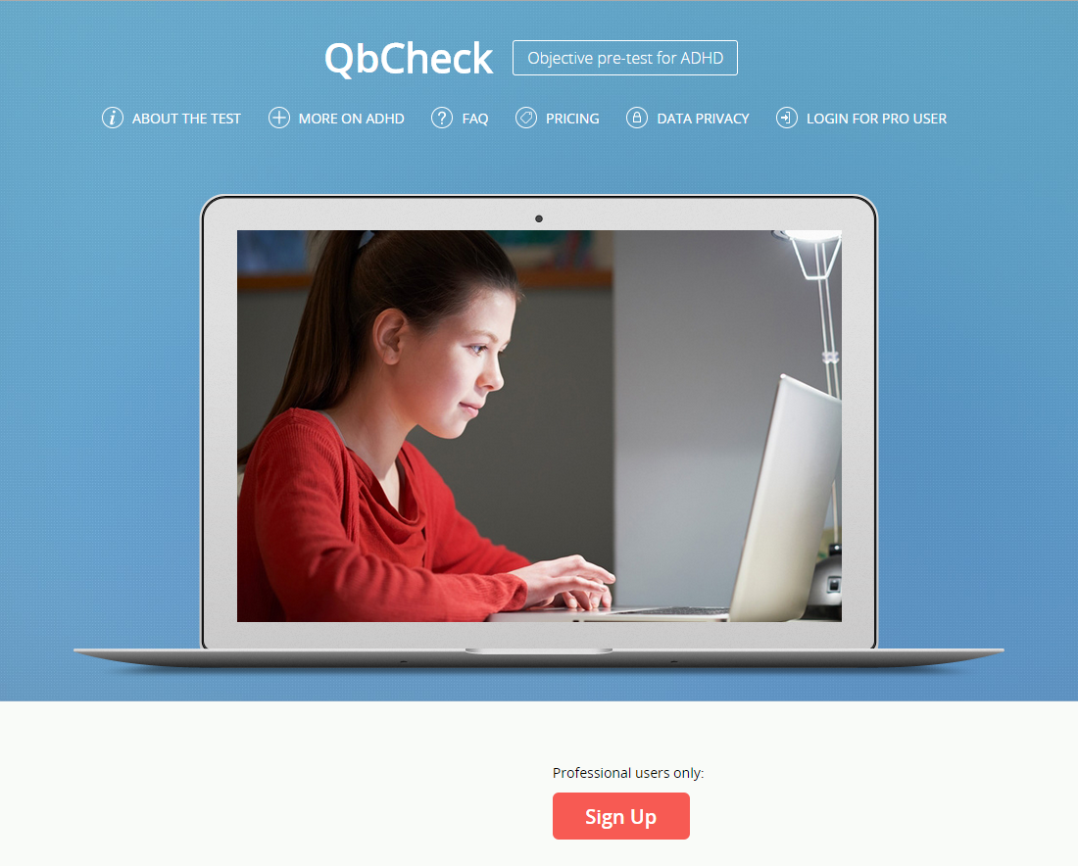

About ADHD

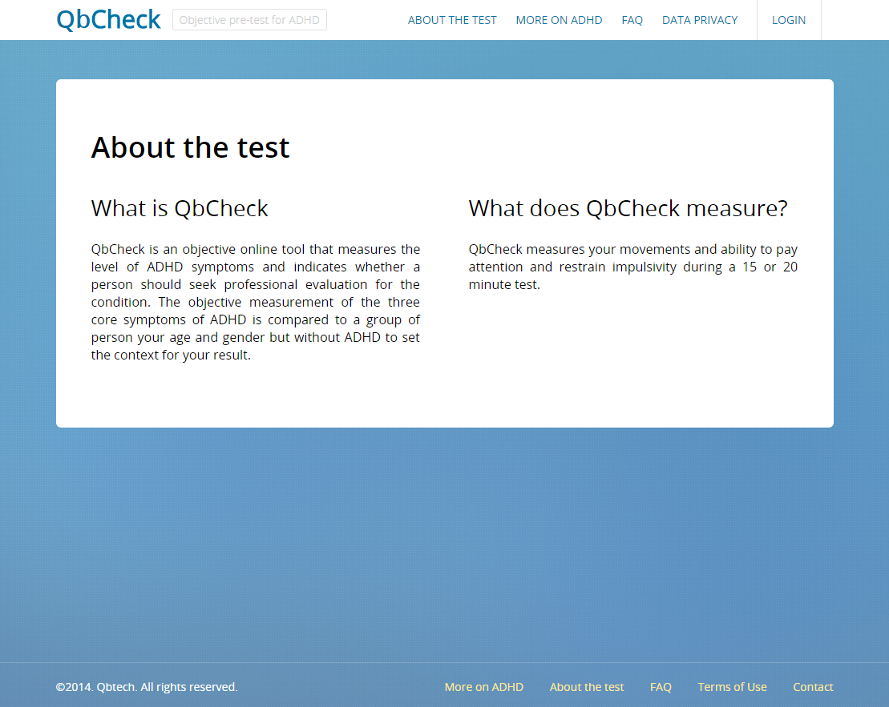

About the test



Log in for pro users

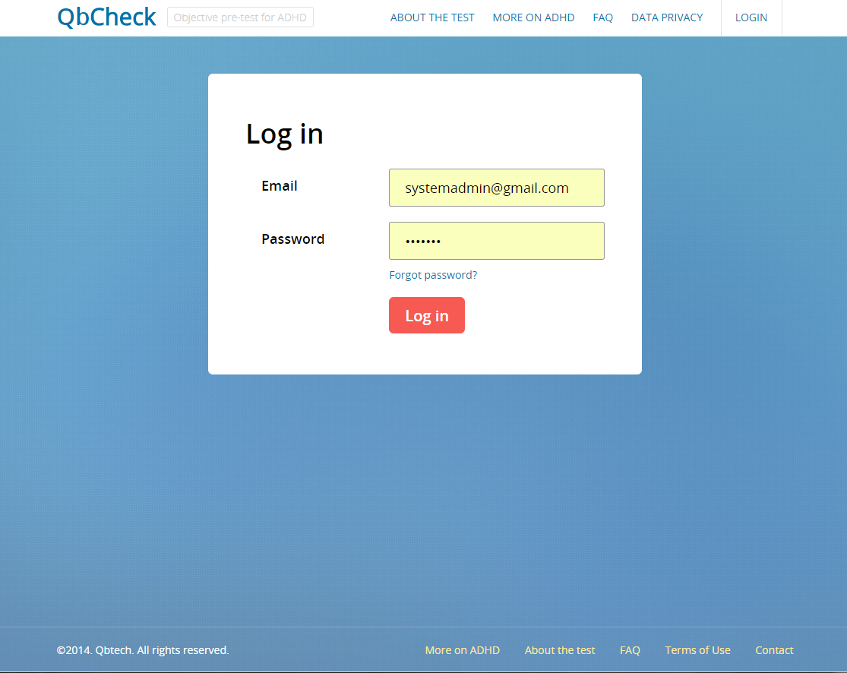

Professional account

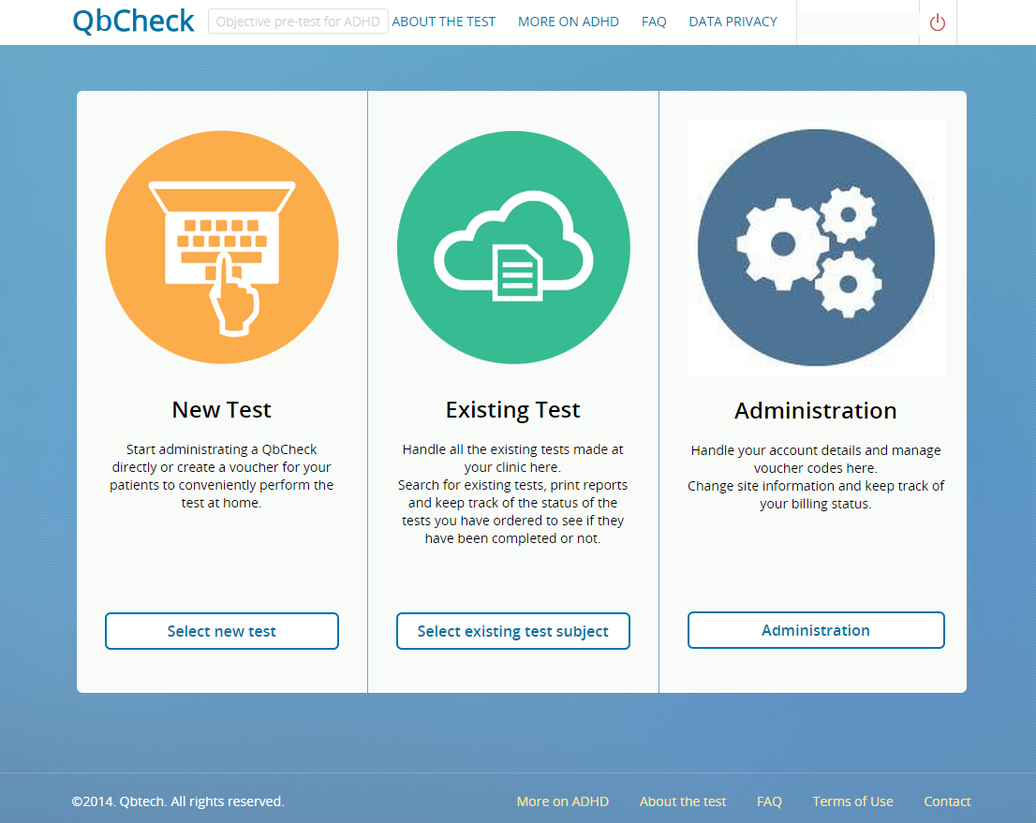

Start a new test

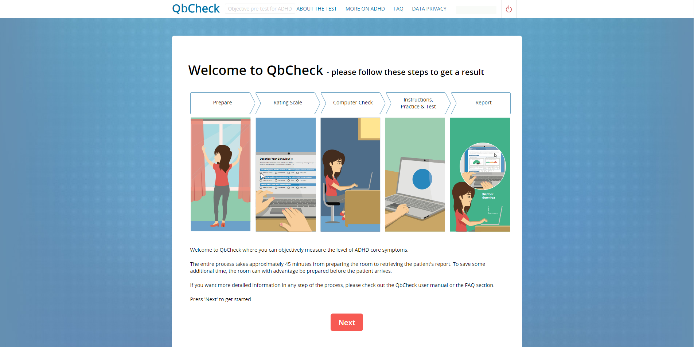

Existing Test

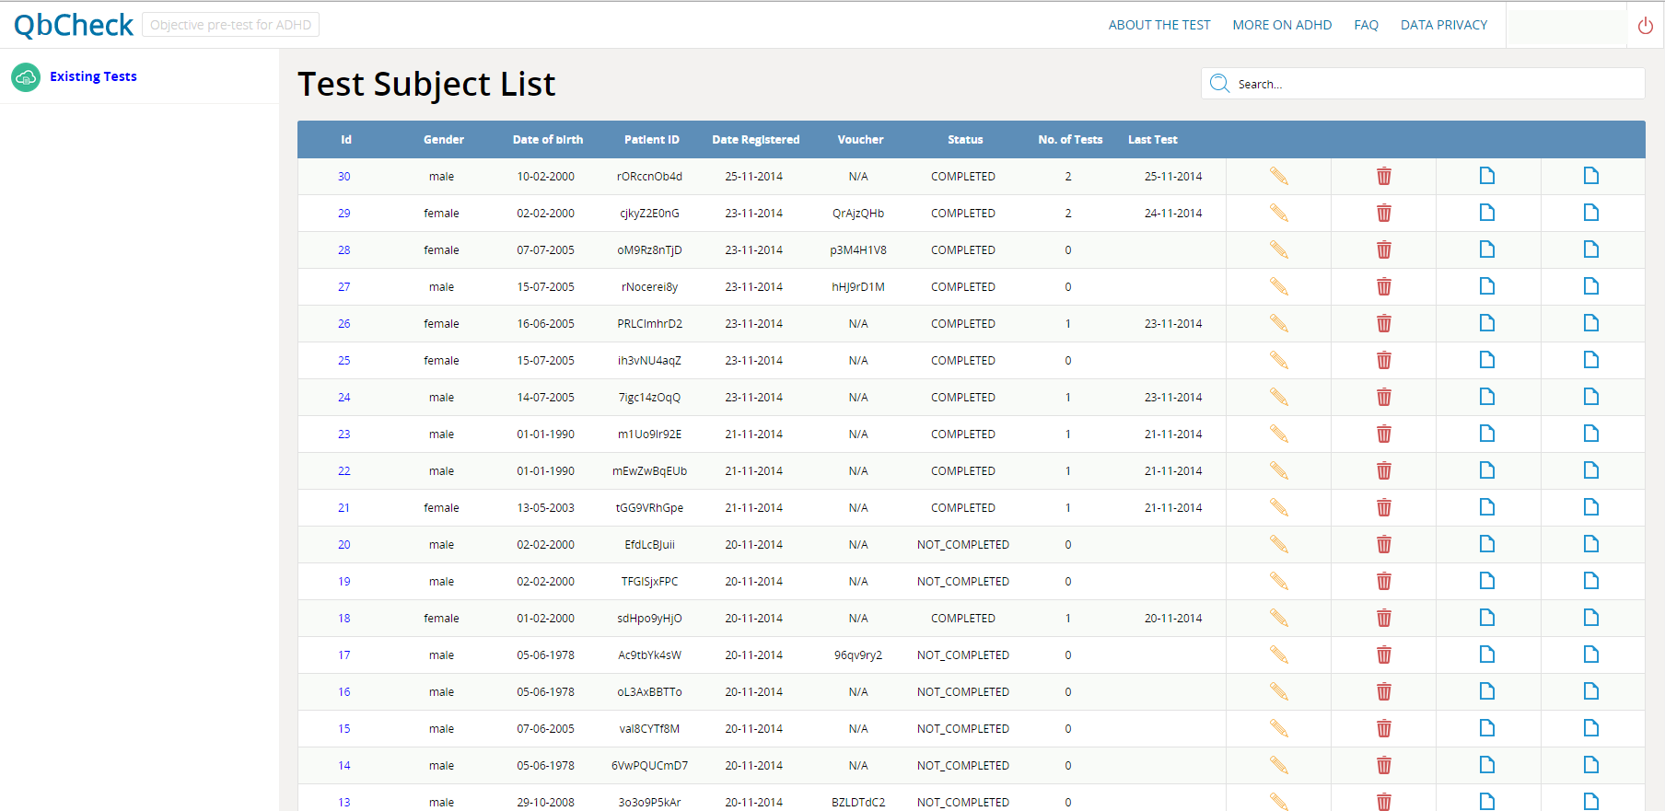

Enter personal data page

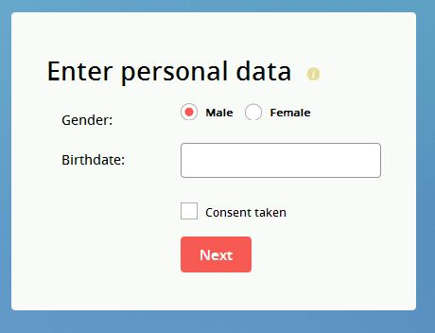

Preparations page

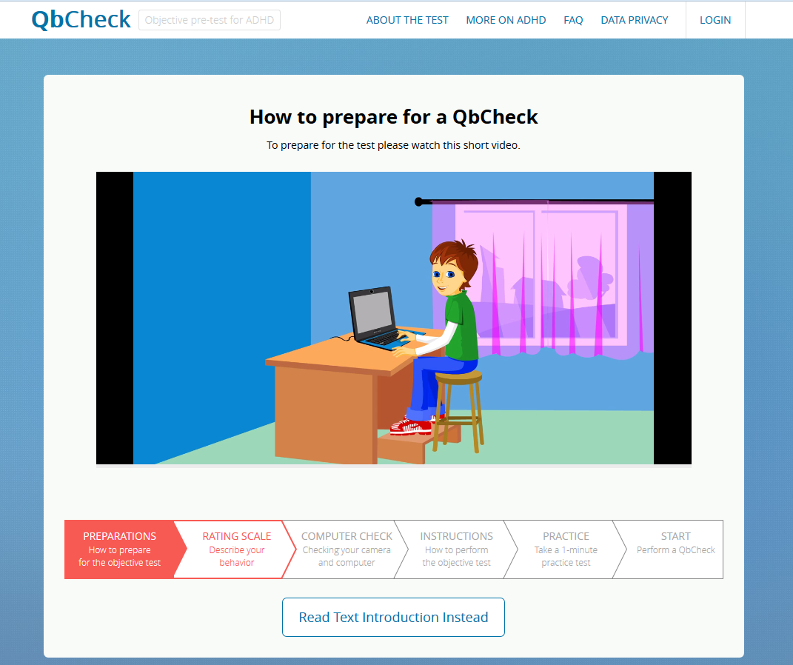

Computer check page

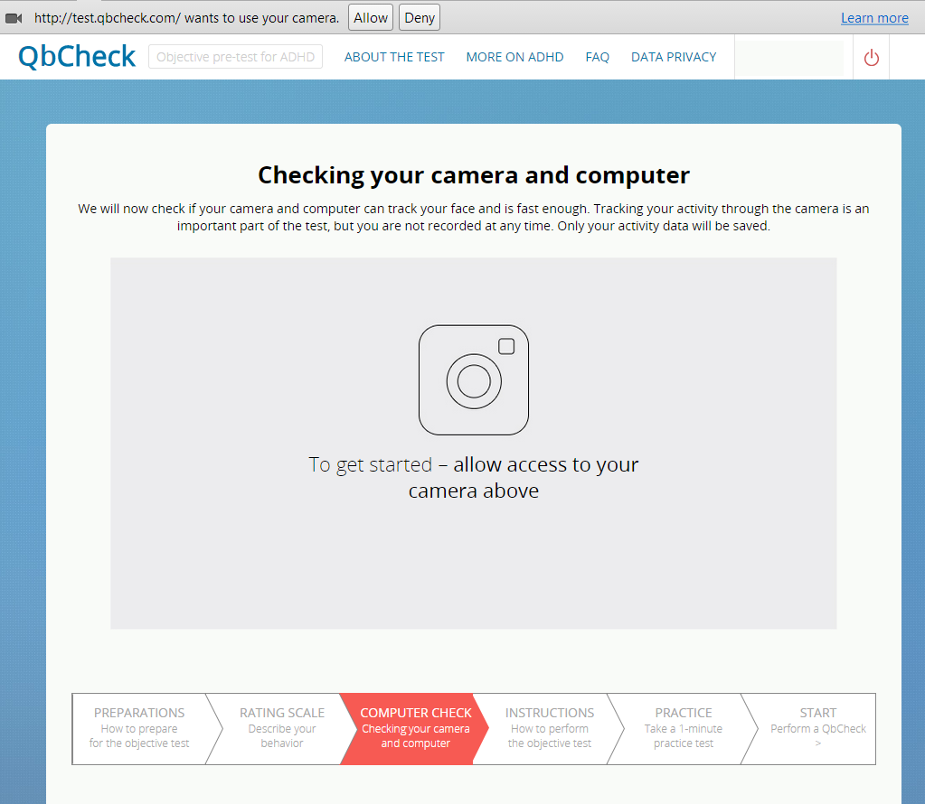

Instruction page

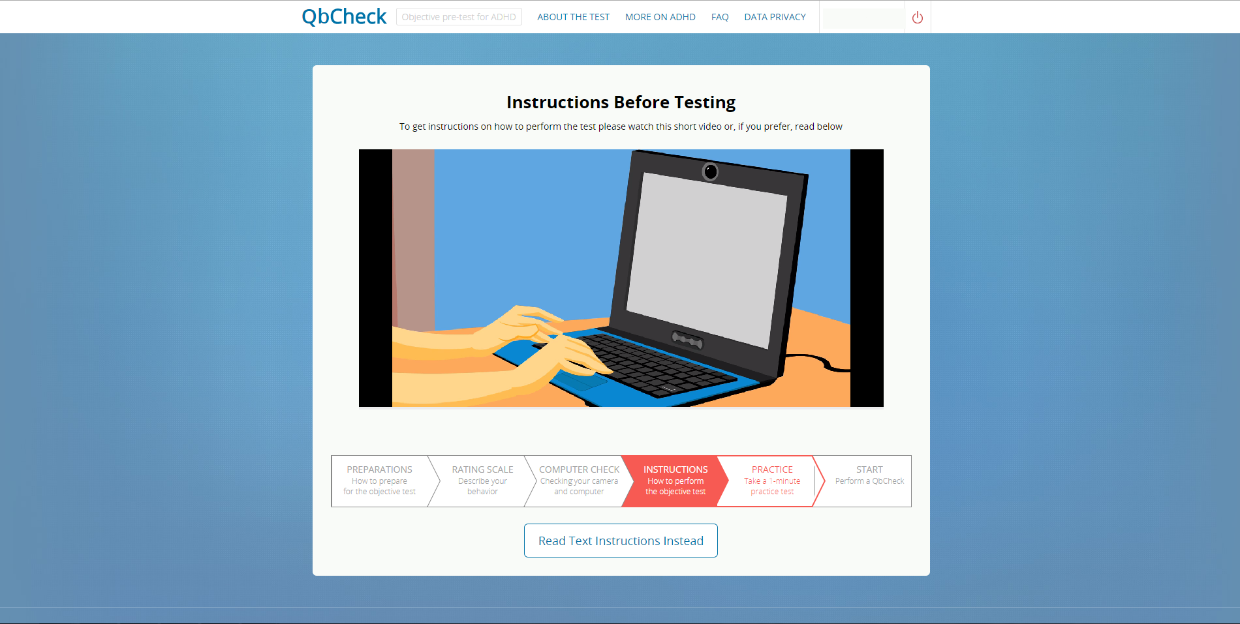

Start QbCheck

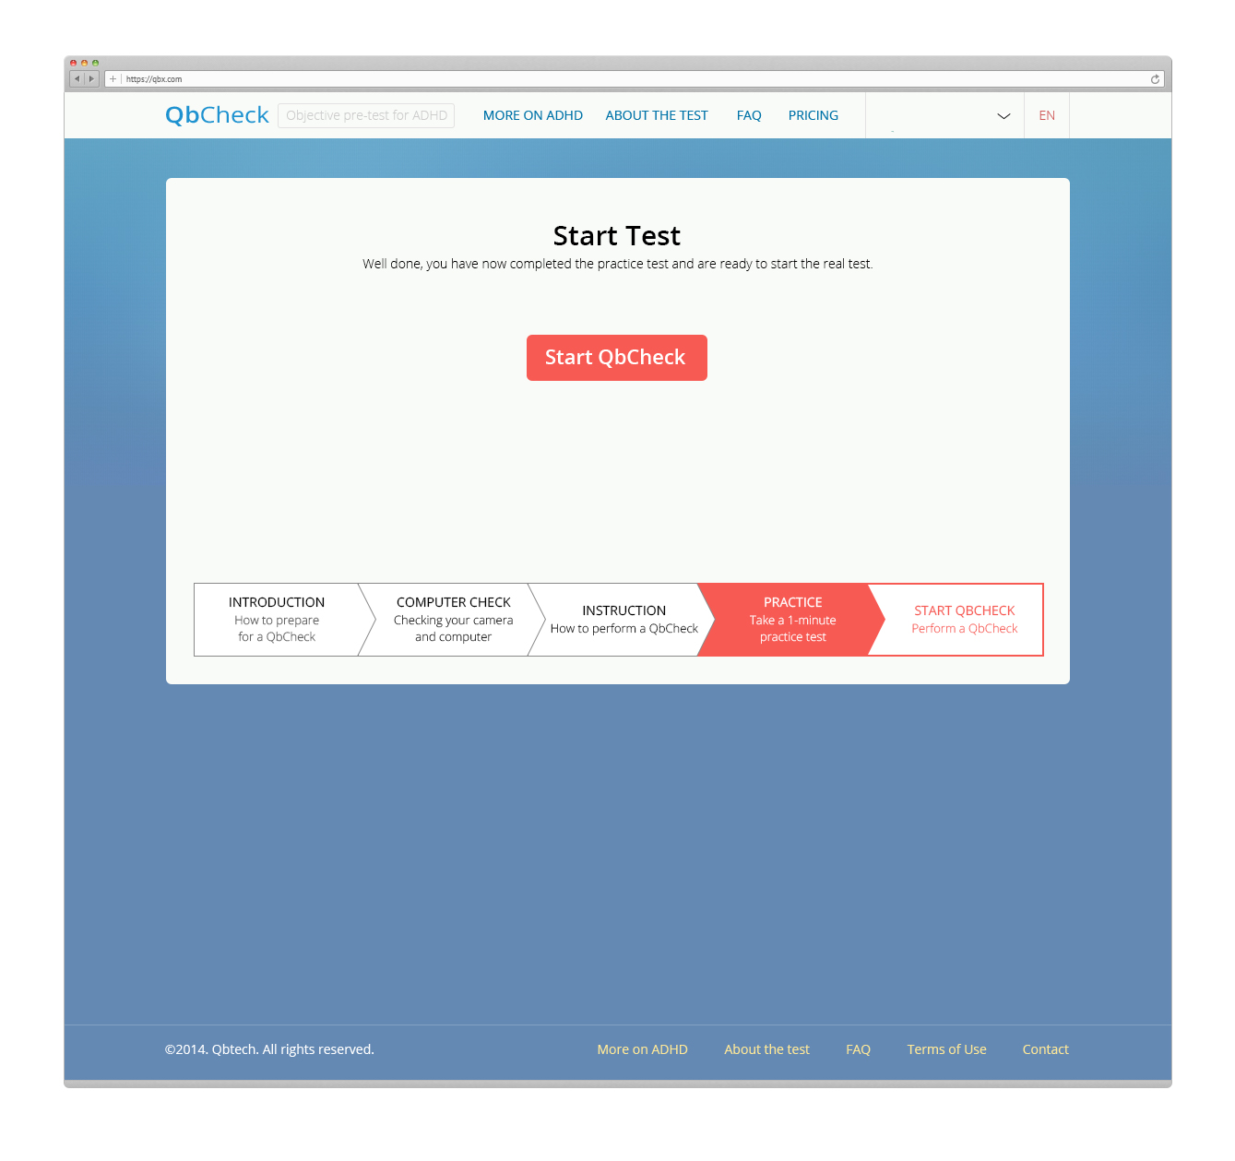

The report page

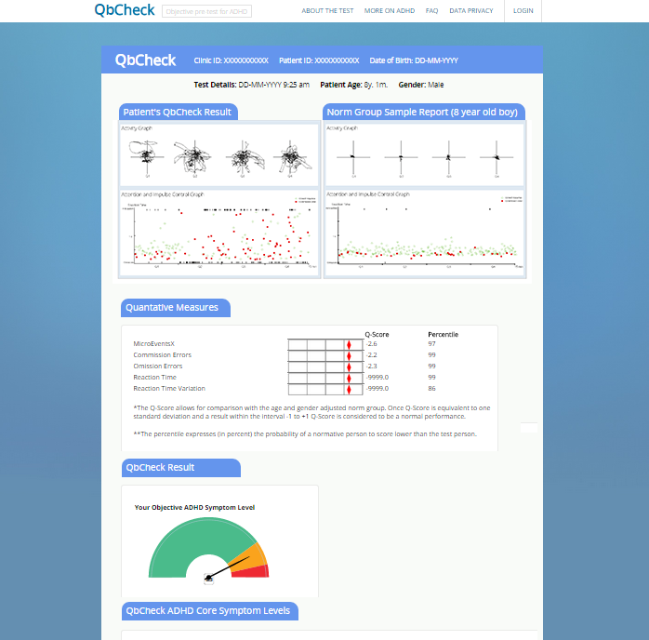

# 

# **3. JavaScript Resources**

Here are the details of the JavaScript resources that have been provided by QbTech team:

| **JavaScript File Name** | **Purpose** | **Any Modifications Required? Details?** |
| --- | --- | --- |
| headtrackr.js | Implementation of the face and the head tracking algorithm (use it as it is) | No modification is required. The only updates are allowed from the origin developer site |
| StimuliGenerator.js | Generation of the sequence of images (target/non-target) in the “random” order. Sequence is generated before the test and saved in array (use as it is) | no modification is required. |
| test.js | the main script. headtracker events handler. There are 4 main events: 1) facetracking (function handleFaceTrackingEvent(event)) - camera follows user's face, coordinates are saved to the array [x,y,time],  2) headtracking (function handleHeadTrackingEvent(e)) - camera follows user's head, ScaleFactor (important parameter for the test result) is calculated. You should not care of the formula for the parameter!  3) user button press (function handler_KeyPress(e)) - only the "space" button press is registered, "esc" is exit from the fullscreen mode,  4) show stimuli on the screen (function handler_getTicks(e) ) - show the picture (target/non-target) on the screen every two seconds.  Can be modified depending on developers point of view | modifications could be done if developers need them |
| main.js | the basic navigation between pages and parameter accumulation | any changes could be done |
| practise_test.js | calculates the omission and comission error in the 1 min test | no |
| json.js | implements the object where test data is stored. The object is converted to the JSON format and sends to the server (test.js) | any changes could be done |